

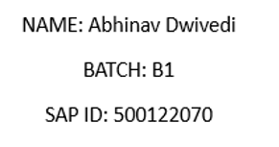

Software Requirements Specification (SRS)

Student Feedback Portal

1. Introduction

1.1 Purpose
The purpose of this Software Requirements Specification (SRS) is to describe the requirements and specifications for the Student Feedback Portal.
This system enables students to submit feedback for courses and allows administrators to manage courses, view feedback analytics, and export reports.

1.2 Scope
The Student Feedback Portal is a full-stack web application designed to:
- Allow students to register, log in, view courses, and submit course feedback.
- Allow administrators to manage courses, analyze feedback, and export reports.
- Provide a secure authentication system using JWT.
- Maintain all records in a MongoDB database.
The system includes:
- A web-based frontend (HTML, CSS, JS)
- A REST API backend (Node.js, Express.js)
- A NoSQL database (MongoDB)

1.3 Definitions, Acronyms, and Abbreviations
Term | Meaning
SRS | Software Requirements Specification
API | Application Programming Interface
JWT | JSON Web Token
UI | User Interface
Admin | Website administrator
DB | Database

1.4 References
- Node.js and Express documentation
- MongoDB Manual
- JWT Authentication standards

2. Overall Description

2.1 Product Perspective
The Student Feedback Portal is a standalone web system.
It consists of:
- Frontend: Browser-based UI
- Backend: REST API server
- Database: MongoDB storing users, courses, feedback
All components interact through secure API calls.

2.2 Product Features
- Student registration & login
- JWT-based authentication
- Submit/edit course feedback
- Course management (admin)
- View all feedback (admin)
- Export feedback as CSV
- Dashboard statistics for admin
- Feedback analytics (charts)

2.3 User Classes and Characteristics
User Type | Description
Student | Can register, log in, view courses, and submit feedback
Admin | Has elevated privileges, can manage system data

2.4 Operating Environment
- Browser: Chrome, Edge, Firefox
- Backend: Node.js 18+
- Database: MongoDB 5+

2.5 Design and Implementation Constraints
- Must use JavaScript (Node.js) for backend
- JWT must be used for authentication
- MongoDB is the required database
- No page should be accessible without login (role-restricted)

2.6 Assumptions and Dependencies
- Users have internet access
- MongoDB and backend must be running for frontend to function
- Admin must manually set role of admin user in DB once

3. System Features

3.1 User Registration & Login

3.1.1 Description
Users can create an account and authenticate themselves using email and password.

3.1.2 Functional Requirements
- System must store unique email for each user.
- Password must be encrypted using bcrypt.
- Successful login should return a JWT.
- JWT must be validated for protected routes.

3.2 Student Dashboard

3.2.1 Description
Students can view all available courses and submit feedback for each.

3.2.2 Functional Requirements
- FR1: Student can view list of all courses.
- FR2: Student can submit feedback with:
  - Rating (1–5)
  - Comment
- FR3: Student can update their previously submitted feedback.

3.3 Feedback Submission

3.3.1 Description
Feedback records are stored in the MongoDB database.

3.3.2 Functional Requirements
- Feedback must be mapped to:
  - studentId
  - courseId
  - rating
  - comments
- Only one feedback per course per student.
- Updating feedback overwrites old values.

3.4 Admin Dashboard

3.4.1 Description
Admins have full control of the system.

3.4.2 Functional Requirements
- FR1: Admin login required.
- FR2: Admin can add courses.
- FR3: Admin can view all feedback in tabular format.
- FR4: Admin can view statistics:
  - total responses
  - average rating per course
- FR5: Admin can export all feedback as CSV.

3.5 Analytics

3.5.1 Description
Admin can view visual charts of feedback data.

3.5.2 Functional Requirements
- Display bar chart using Chart.js
- Compute average rating per course
- Fetch all feedback via REST API

4. External Interface Requirements

4.1 User Interface

Student UI:
- Login Page
- Signup Page
- Course List
- Feedback Form

Admin UI:
- Dashboard
- Add Course
- Feedback List
- Analytics Page

4.2 Hardware Interface
None (web-based).

4.3 Software Interface
- Browser
- Backend API (JSON)

4.4 Communication Interface
- HTTPS/HTTP requests
- JSON payloads
- REST API format

5. Non-Functional Requirements

5.1 Performance Requirements
- API should respond within 2 seconds.
- System must support 100+ students concurrently.

5.2 Security Requirements
- Passwords hashed using bcrypt.
- JWT used for authorization.
- Role-based access enforcement.

5.3 Usability Requirements
- Clean UI with simple navigation.
- Mobile-friendly pages.

5.4 Reliability
- Database must ensure ACID properties through MongoDB.
- Server must handle network failures gracefully.

5.5 Maintainability
- Modular folder structure.
- MVC architecture used.

6. Database Requirements

Collections:
- Users
- Courses
- Feedback
Each has unique object structure defined using Mongoose schemas.

7. System Models

7.1 Use Case Diagram

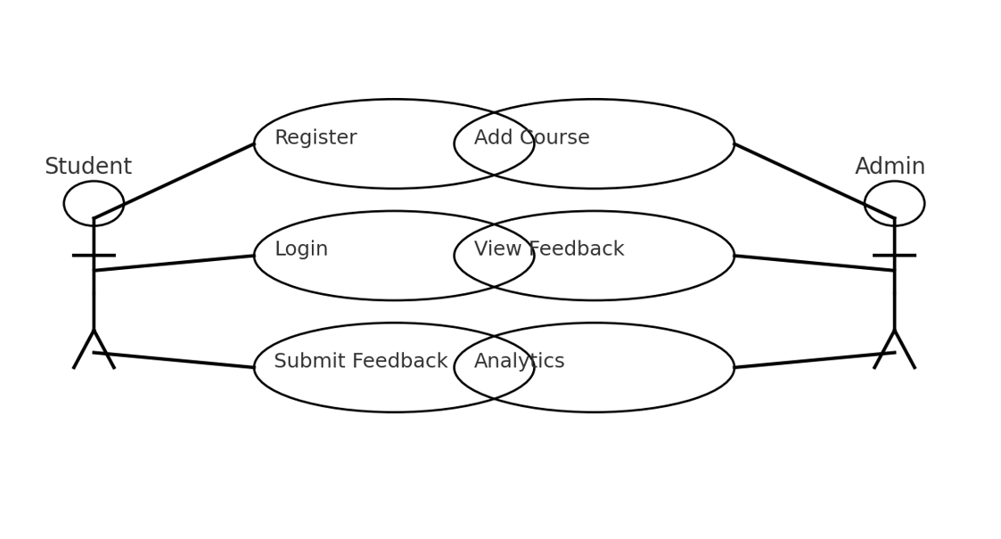

7.2 Class Diagram (Text Form)

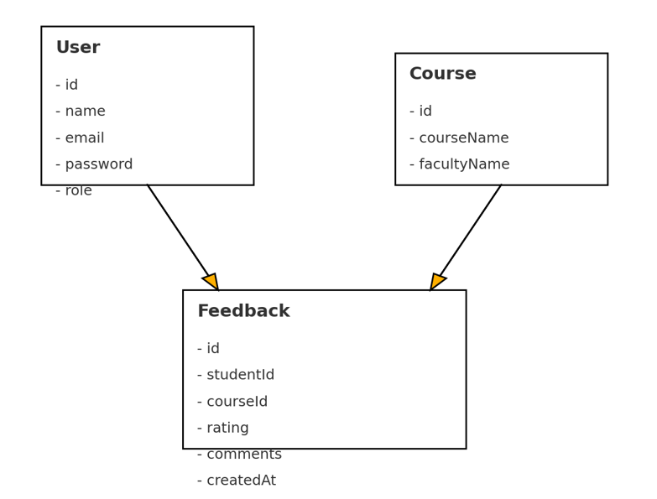

7.3 Sequence Diagram
